To: Lakeside Cemetery Family Members, Property Owners, and Friends

From: City of Conway – Lakeside Cemetery Committee

Lakeside Cemetery Committee is committed to preserving and maintaining the historical integrity and beauty of the Lakeside Cemetery. The City of Conway maintains the cemetery by removing trash and mowing. Since this is not a perpetual care cemetery, property owners and their descendants are responsible for the upkeep of individual plots.

In order to preserve and beautify the cemetery, funds have been collected through the years from property owners and benefactors. These contributions funded the following projects to name a few:
1) New Columns for Both Entrances
2) Gates for Both Entrances
3) Lighting for the Columns
4) Roof Repairs to the Gazebo
5) Brick Flooring inside of the Gazebo
6) A Fountain near the Main Entrance
7) A Walkway around the Fountain
8) A Cross Erected near the Main Entrance
9) Repairs/Replacement of Doors to Mausoleum
10) A Plaque on the Mausoleum

Your tax deductible contribution(s) to Lakeside Cemetery helps to continue the effort to beautify and maintain this historical setting. Please consider making or having donations made in honor of or in memory of your loved ones or consider making a bequest.

A contribution form is available online for your convenience at: http://cityofconway.com/images/Contribution_Form.pdf

Thank you for your support to help preserve, beautify, protect, and provide for the continued upkeep and maintenance of our historical Lakeside Cemetery.

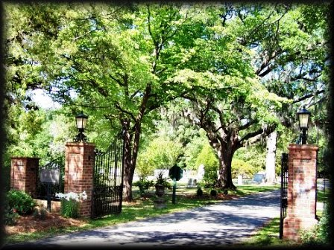
Sincerely,
City of Conway
Lakeside Cemetery Committee
4/7/2016

